**Name:** Henry Salgado

**CS 4351/5352: Computer Security**

**Assignment 1: Linux Basics**

1. Based on the information provided above, list each user's permissions for each file on both directories.

**Directory: cs4351**

Owner: seed

permisions: the owner, group and other can read, write, execute

**answers.txt:**

* Owner: prof
* Group: ta
* Permissions: -rw-r--r--
  + prof (owner) can read and write.
  + ta (group) can only read.
  + Others can also only read.

**assign1.txt:**

* Owner: ta
* Group: student
* Permissions: -rw-r--r--
  + ta (owner) can read and write.
  + student (group) can only read.
  + Others can also only read.

**assign2.txt:**

* Owner: ta
* Group: student
* Permissions: -rw-r--r--
  + ta (owner) can read and write.
  + student (group) can only read.
  + Others can also only read.

**assign3.txt:**

* Owner: ta
* Group: student
* Permissions: -rw-r-----
  + ta (owner) can read and write.
  + student (group) can only read.
  + Others have no permissions.

**cheatSheet.txt:**

* Owner: student
* Group: student
* Permissions: -rw-r-----
  + student1 (owner) can read and write.
  + student (group) can only read.
  + Others have no permissions.

**tests directory:**

* Owned by prof, the group is ta.
* Permissions:
  + prof (owner) can read, write, and execute.
  + ta (group) can read and execute.
  + Others can read and execute.

**answersExam1.txt:**

* Owner: prof
* Group: ta
* Permissions: -rw-r--r--
  + prof (owner) can read and write.
  + ta (group) can only read.
  + Others can also only read.

**answersExam2.txt:**

* Owner: prof
* Group: ta
* Permissions: -rw-r--r--
  + prof (owner) can read and write.
  + ta (group) can only read.
  + Others can also only read.

**exam1.txt:**

* Owner: prof
* Group: student
* Permissions: -rw-rw-r--
  + prof (owner) can read and write.
  + student (group) can read and write.
  + Others can only read.

**exam2.txt:**

* Owner: prof
* Group: student
* Permissions: -rw-rw-r--
  + prof (owner) can read and write.
  + student (group) can read and write.
  + Others can only read.

**stdtExamPerf.txt:**

* Owner: prof
* Group: prof
* Permissions: -rw-rw----
  + prof (owner) can read and write.
  + prof (group) can read and write.
  + Others have no permissions.

1. Now that you have identified which permissions each user has...

A) Can a user, **student1**, delete a file from **the cs4351** directory?

**Since student1 has write permission on the file directory, they could technically delete a file.**

b) Which user(s) can create a file from the **tests** directory?

**Both the professor and TAs have write permissions on the test directory.**

c) Can user ta1 modify stdtExamPerf.txt?

**No, since ta1 does not have permission to modify since they are not members of the group.**

d) Which users can modify the content of answers.txt?

**Both the prof and the tas have read and write permissions.**

e) Which Linux command would you use to give reading permission to the user ta1 to the cheatsheet.txt file using the octal notation?

**chmod 640 cheatsheet.txt**

f) Which Linux command would you use to remove the reading and writing permissions to the user student1 to the exam1.txt file using the symbolic notation?

**chmod g-rw exam1.txt**

**Part II (50 Points)**

For this part, you are **required to use your SEED Labs Virtual Machine** to run some basic Linux commands. Please provide screenshots of the results after running the commands for each question.

1. Which command would you use to add a new user called janeDoe?

**sudo useradd janeDoe**

1. Once you have created the new user, provide a password for that user

**sudo passwd janeDoe**

1. Now, which command would you use to create a group named student?

**sudo groupadd student**

1. After creating the group student, add the new user, janeDoe, to be part of that group and display that the user was added correctly.

**groups janeDoe**

1. Next create a directory named cs4351Assgn inside the seed home directory. Move to the newly created directory and display the directory items.

**mkdir cs4351Assgn**

**Note:** I do not have a seed home directory (I am on a linux not a virtual machine), so I just made directory in my own home directory.

1. Which command would you use to create a file named test.txt inside the cs4351Assgn directory?

**cd cs4351Assgn**

**touch test.txt**

1. Next, display the permissions granted for the file and the directory you have created.

**ls –al**

1. Which permissions are granted to the user janeDoe for the test.txt file you created?

**None, since janeDoe is not part of the group**

1. Grant user janeDoe writing permission for the file test.txt if needed.

First, I change group of the directory cs4351Assgn to student (since JaneDoe is part of that group)

**Sudo chgrp student cs4351Assgn/**

I display permissions to see if group was changed

**Ls – al**

And double check that janeDoe is part of the student group

**Getent group student**

From here, we can give writting permissions to group (student) and consequently janeDoe by a

**sudo chmod g+w cs4351Assgn**

Part a – e

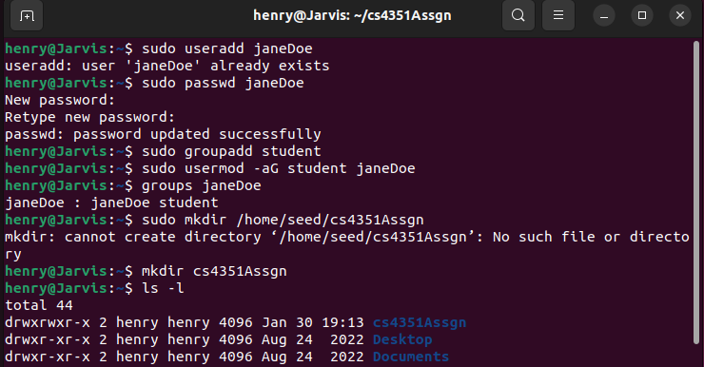

Part f - h

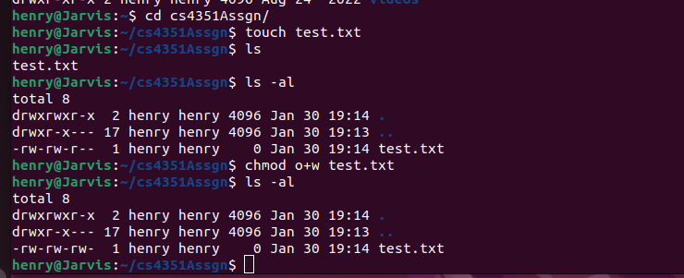

Part i

